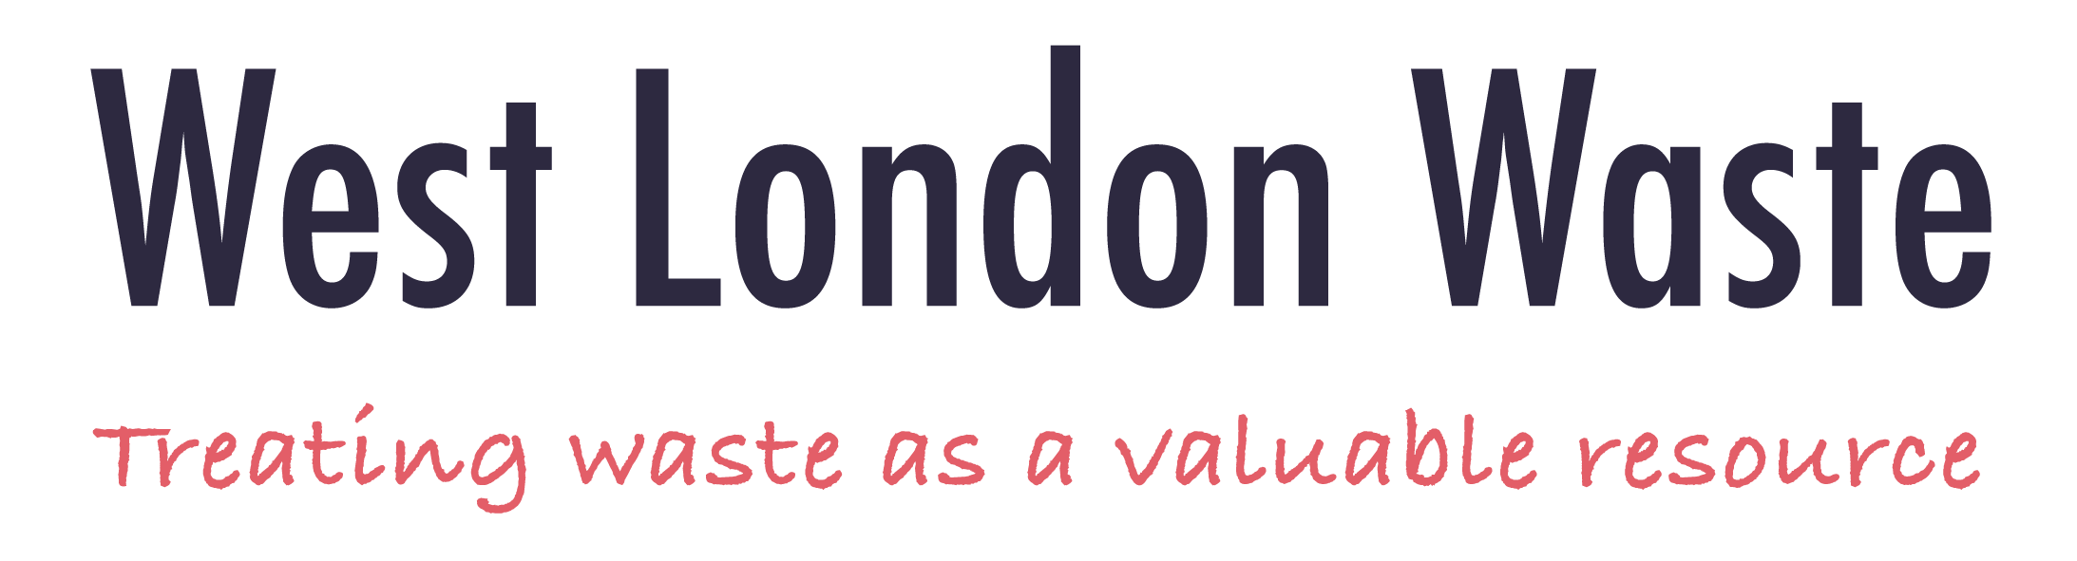

West London Waste
IT Strategy
(Data, Digital & Technology)
2024-2029

IT Strategy Pyramid ……….…………………………………………..3
Overview…………………………………….…………………………..4
1.Vision Statement……………………………………………………..4
2.Executive Summary………………………………………………….4
3.Introduction……………………………………………………..…….5
4.Strategic Context……………………………...………………,…….7
5. Strategic Priorities/Activities….………..…………………………..8
6. Strategic IT Goals……………………………..………………..….10
7. Security & Compliance…………………...…………………….....11
8. IT & Data Governance…………………….……...……………....12
9. Continuous Improvement ……………………………………...…13
10. Digital Transformation……………………………………………13
10.1 Website…………………………………………………………..13
10.2 Cloud First………………………………………………..……...13
10.2.1 Cloud Migration…...………………………..…………14
10.2.2 IT Roadmap……………………………….…………..14
10.2.3 Employee Engagement………………………….......14
10.2 Business Reporting……………………………………….…….15
10.3 Artificial intelligence / Automation…………………………..…15
11. Timeline……………………………………………………….…..16
12. Resourcing…………………………………………………….…16
Appendix 1…...…………………………………………………….…16
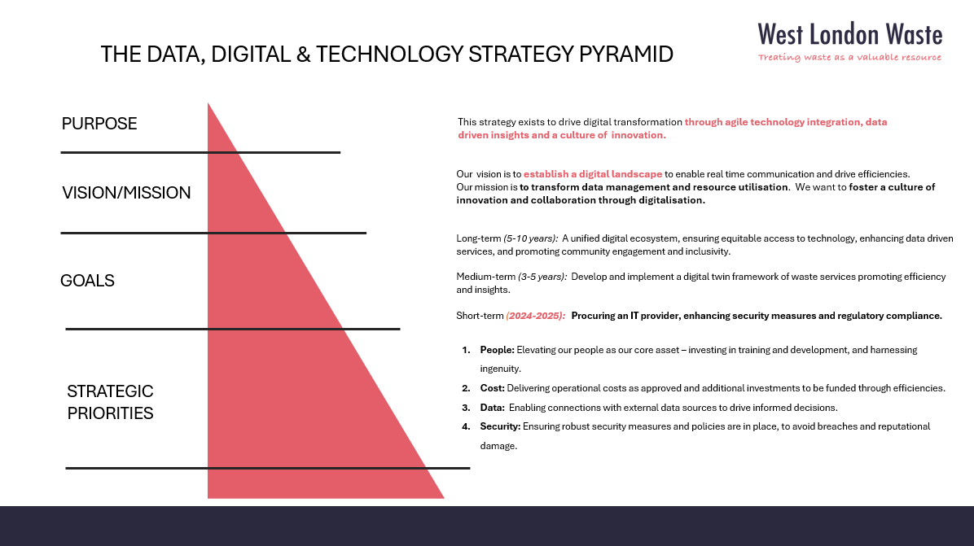
Overview
In 2018, West London Waste Authority (WLWA) underwent a significant transition, shifting from a shared IT infrastructure with L.B of Ealing to adopting an independent virtual server-based environment managed by an external IT provider. The previous IT Strategy centred around Citrix virtual desktop solutions with remote servers managed by an external provider, aiming to provide remote access and enhance workforce flexibility. At the time of implementation, the approach aligned with prevailing trends and addressed immediate needs for remote collaboration. The Citrix virtual desktop infrastructure served its purpose by facilitating remote working; however its recent limitations, including performance issues and constrains on data access, have become increasingly apparent.
A notable shift in priorities within WLWA has emphasised the importance of leveraging data as a strategic asset for informed decision-making and operational efficiencies. As WLWA transition into the current landscape, it has become evident that the current strategy is now out of date and possibly limiting our potential for data driven efficiency and innovation. The current IT landscape demands a more agile and data driven approach to meet evolving business requirements to better support its constituent Borough and stay competitive in a dynamic environment.

1. Vision Statement
Establish digital transformation through agile technology integration, data driven insights and a culture of innovation in partnership with Boroughs and residents for inclusive and impactful progress.

2. Executive Summary
The IT strategy has been developed to integrate data driven decision making, relevant technology, and digitalisation of waste services. The strategy recognises collaboration as a priority for the Authority, fostering teamwork with internal and external stakeholders including data sharing and interpretation.
Over the last 3 years, WLWA has evolved and developed its strategic priorities. This necessitates an update to our IT Strategy, moving towards a more comprehensive and flexible approach that embraces new developing technologies. As we progress on this update, the goal is to develop the Authority’s data analytics, automation, and scalable infrastructure.
The strategy will require a review of the current infrastructure coupled with strategic enhancements to software and hardware system. We will ensure that we keep security and useability at the forefront, and that the integrity and accessibility of our systems are safeguarded. This approach ensures not only operational efficiency but also allows for support to be provided to our Boroughs for sustained growth in an evolving digital landscape.
Our strategy places a significant emphasis on sustainability, efficiency, support for digital transformation of the waste industry, robust cybersecurity, and industry standard legal compliance.
We aim to create a resilient foundation that not only meets the immediate needs but also anticipates future challenges of the waste and environment industry, contributing to a secure, sustainable, agile, and efficient digital future.
3. Introduction
3.1 IT plays a crucial role in the daily operations of the Authority, contributing to the realisation of its strategic objectives. The IT Strategy enables clear connections and outlines the strategic IT priorities aimed at addressing future requirements.
3.2 The Strategy spans over a duration of five years, recognised as the payback period/lifecycle for technology investment, providing an appropriate timeframe for implementing actions outlined in the strategy.
3.3 An annual review of the strategy will ensure it remains current and effective in adapting to evolving circumstances.
3.4 The principal role of IT is to facilitate the effective and agile management of the Authority’s key organisational activities and delivery of its 5 strategic priorities. These key activities and priorities are fundamentally underpinned by data, emphasising the critical role of information in guiding and optimising data driven decision making processes.

- Citizen Perception
- Data Driven Efficiency
- Social Value and Re-use
- Increase Access
- Organisation Excellence

Key Activities:
- Contracts and Procurement – Management and administration of procurement activities and contracts (e.g. preparation of tender proposals and evaluation, ensuring compliance with legal and regulatory requirements, understanding demand and waste flows, managing contractor service delivery, optimising costs, dealing with multiple contracts, Borough liaison)
- Operations – Managing the L.B. Brent Household Re-use and Recycling Centre (Abbey Road), support L.B of Richmond by advising on their Central Depot and Townmead Road sites (e.g. site management, Health & Safety, weighbridge, maintaining assets & equipment, reuse activities and providing cost efficiencies)
- Projects - Borough partnership and promoting circular economy initiatives with cost efficiencies. (e.g. corporate governance, resident feedback, waste comp analysis for reduction of residual waste, creating a digital twin of WLWA and borough services).
- Corporate Services – Managing organisation wide and central functions (e.g. HR services, financial transaction processing, ensuring effective financial control, reporting key performance indicators, management information, data validations and reporting, facility management, IT core functionality)
3.5 Through the strategic integration of data, digitalisation and technology, IT acts as an enabler, supporting the Authority in achieving its goals with efficiency and adaptability, ultimately enhancing overall organisational effectiveness.
3.6 The key stakeholders in relation to the IT strategy are all the Authority’s employees, the Boroughs and the residents.
3.7 The Authority’s current IT service is provided by an external IT provider as detailed below:
IT system | Networked / Cloud / Stand-alone* | Delivered by
Infrastructure hardware including equipment (2 remote servers, laptops, Printers etc.) | Cloud | Kick ICT
Infrastructure communications (data lines, routers, wireless networks, internal office wiring etc.) | Networked | Kick ICT
Infrastructure software  Via Citrix virtual desktop (security, backups, networking, file structures, user management etc.) | Cloud | Kick ICT
Other applications (use of Microsoft suite, outlook, PowerBi for reporting) | Mixture | Kick ICT
Core waste data management application via SaaS product iWDMS (processing waste movements, EA returns) | Cloud | Opensky
Core finance application, Unit 4 SaaS product (invoice processing, accounting etc.) | Cloud | Unit 4
Core civic amenity application (weighbridge operation, waste data) | Stand-alone | InfoTech
Web management (including website hosting) and social media | Mixture | Nasstar/Coopa
Banking applications (BACS transmissions, electronic banking, taking card payments) | Mixture | PCF, HSBC, Global payments
Peripherals (laptops for weighbridge, CPU for ANPR, CCTV monitoring, projectors etc.) | Stand-alone | WLWA/DSSL
Booking System for residents | Cloud | Pentagull
HR System (for payroll, recording of absence, expense, annual appraisals and 1-2-1s) | Cloud | ITrent HR and Payroll (SLA with L.B of Ealing)  Lattice

The table highlights the main IT functionality and provides a picture of the current use of IT. This is not an exhaustive list.

4. Strategic Context
4.1 The Joint Waste Management Strategy (JMWMS) framework agreed in March 2022 uses a waste reduction / circular economy / decarbonisation approach to reduce the likelihood of overspending. This has the co-benefit of promoting carbon reduction measured as the carbon embedded in waste. The framework provides a foundation for the Authority’s key strategic priorities over the coming years and the IT Strategy will be a key deliverable to support these.
4.2 The main strategic drivers that determine the Authority’s approach to IT are detailed below.

    - Activities - the Authority’s range of activities to achieve its key strategic priorities is the principal factor which needs to be delivered and managed through effective use of IT. An agile IT infrastructure which is regularly assessed will ensure it remains aligned with the evolving needs of the organisation.
    - People - the Authority employs approximately 40 employees performing a diverse range of roles. This is evenly split between Abbey Road and West Drayton office with a hybrid style of working. The Authority recognises that the greatest asset is our people and promotes collaboration, innovation, diversity and inclusion within our teams. We are committed to fostering a culture of continuous learning and development to have a skilled and adaptable workforce.
    - Location - Whilst we have two locations which will provide progressive IT solutions in terms of hardware, communications and infrastructure we also recognise the importance of flexible working. Our approach looks at flexibility and acknowledges the benefits of a distributed workforce. We are committed to investing in secure and efficient collaboration tools, ensuring our team members can seamlessly contribute from various locations. This enhances our organisational resilience. We are dedicated to providing a virtual work environment that promotes productivity, effective communication and the well-being of our workforce.
    - Cost - Amidst notable spending constraints in Local Authority, the importance of cost and efficiency remains paramount in procurement and implementation of IT services. We ensure to maintain a focus on delivering solutions that are both cost effective and efficient for IT in this challenging financial context. There is an approved Capital Budget of £400,000 for implementation and development over the next 4 years and dedicated annual IT service costs budgeted FY 24/25 of £140,000.
    - Data - the Authority uses data to guide its decisions, activities and investments to drive innovation and operational excellence. It recognises the strategic importance of acquiring, managing and analysing data, placing it at the core of its technological endeavours.
  - These key drivers determine the IT Strategy and are detailed in the following sections.

5. Activities – Strategic Priorities
The delivery of the strategic priorities has been encompassed as part of the core functionality at each departmental level. These activities are the principal drivers of the Authority’s use and need of IT.

Strategic Priorities linked to Activities | Need of IT Use | Cross Functional Teams
Citizen Perception - Baseline West London Citizen’s perception of value of waste | - Data gathered for insights profile work from key stakeholders. This will be linked to data modelling ensuring encryption, security and usability.  - Using data analytics to create new insights for decision making, ultimately helping Borough’s understanding of residents and opportunities to create savings.  - Developing smart device skills to improve resident’s access to their waste and recycling days and advice about reuse and circular economy initiatives. | Projects, MI & Finance
"Reuse" Social Value -  Measure & Scale up the "Social Value" of Re-Use in order to maximise value and educate more efficiently | - Inventory management of the CE hub(s).  - Ecommerce platforms for management of payments.  - EPOS system for the hub(s) and associated technology.  - IPADs, mobile devices with accompanying technology to help integrate data from source at HRRC to capture data for new initiatives.  - Compatibility and linking of the social value tool.  - Programme Dashboards (higher capability of Powerbi).  - Recording of KPI. | Operations, Projects, MI and Finance, Contracts & Procurement
Data Driven Efficiency - Create a digital twin of waste services to identify and implement improvements | - Creation of a digital twin of WLWA and borough services on a suitable platform that is able to evolve over time with continuous inclusion of data sources. | MI & Finance, Projects, Contract & Procurement
Increased Access -  Expand food, re-use, e-waste & textile waste capture to include more of West London | - Incorporation of ANPR/CCTV data.  - Modelling waste flows to better understand trends to help with contract management and operational efficiencies.  - Linking in with citizen perception, ensuring residents have the relevant services needed to reduce waste. | Projects, MI & Finance, Contracts and Procurement
Organisational Excellence -  Invest in & improve our people, systems and governance to driver greater outcomes | HR, Governance and Systems:  - Creation of robust policies and procedures accessible through a one stop shop.  - Creating of H&S digital platform.  - HR system which is suitable for the evolving needs of the Authority.  - IT Systems up to date and secure. | All

In overall terms, the IT Strategy is about ensuring a suitable range and quality of functionality of IT services whilst constantly reviewing operations to see if there are new technologies and processes that could improve efficiencies.

6. Strategic IT Goals

WLWA will create goals that are specific, measurable, achievable, relevant and timely (S.M.A.R.T) to the overall strategic priorities. The IT Strategy is designed to aid decision making and innovation across the organisation and utilise emerging technologies for cost and operational efficiencies. The following changes will help align with the strategic priorities.
- Ensures the business is capable to move forward with relevant technologies by addressing fundamental limitations in the current setup.
- Up to date IT systems to allow for scalable, secure, controlled growth (for example moving away from Citrix), while ensuring changes that are made are both financially and environmentally conscious.
- Ensure relevant training is provided to all staff to deliver on the IT strategy.
- Ensure all employees are provided with the right IT infrastructure to carry out their roles to the best of their ability.
- Enhances IT compliance along with Device and Data security (Intune, CA etc.)
- Bolster IT Disaster Recovery and Business Continuity (Backup & DR) reducing the impact of a security incident.
- Introduce new technologies to help drive efficiency (Power BI or relevant, AI)
- Look for improving ROI on current IT expenditure.
- Create a sustainable and scalable IT environment.
These will be provided once a new IT provider has been procured and documented accordingly. These will form part of the annual review.

7. Security & Compliance

Security is a high priority, there needs to be protection against multiple different threat landscapes and alignment with the relevant IT Governances. Good security and compliance can help WLWA build greater trust with external parties in the assurance that this is a safe and secure environment. Some examples of this include.
- Device Management to allow for the control of devices that are accessing the network and company resources.
- Conditional Access policies could be leveraged to help control who can access what elements and aspects of the network.
- Data and Device Encryption, ensuring devices are encrypted and that data is encrypted in transit. This will help safeguard against data loss and ICO reportable incidents. Examples of data in transit encryption include only allowing encrypted USB drives for taking data offsite.
- Leveraging cloud for storage would allow for the implementation of data tagging and implementation of Data Loss Prevention controls. This would help minimise the risk of people accessing and sharing sensitive data that does not align with the IT Data Governance policies.
- Annual Pen testing will ideally be implemented as this is becoming more of a mandate from Government Organisations and Insurance companies for the issuance of Cyber Insurance. This will help identify gaps in the network security that could potentially be used by malicious actors to compromise the network.
- Monthly KPIs with our IT provider ensuring security is not compromised and recognising what controls and checks have been put in place.

8. IT & Data Governance

Effective governance ensures that the IT investments support the strategic goals. Governance provides a framework for decision-making, ensuring that decisions are made based on priorities, goals, and values. This helps to reduce risks, improve outcomes, and optimise resource allocation. Governance provides mechanisms for oversight and accountability, ensuring that stakeholders are responsible and accountable for their actions and decisions.
Some of the frameworks WLWA would benefit from adopting are.
- FAIR: A framework that helps organisations quantify and manage information risk using standard risk terminology and models.
- GDPR
- Cyber Essentials
Additional frameworks will be added as they become relevant.
To foster a data-driven approach across the Authority, and its stakeholders, we will be implementing a robust data governance framework that prioritises secure data collection, management, interpretation and sharing. Leveraging a secure cloud infrastructure, we will ensure data resides in compliant regions, implementing encryption, access controls and interoperability standards for seamless collaboration.
Our strategy includes the establishment of clear roles, staff training and continuous monitoring to maintain data privacy and security. By cultivating a culture of responsibility and collaboration, we aim to facilitate secure and efficient data sharing while staying compliant. The initiative not only enhances our data driven decision making capabilities but also establishes a foundation for long term collaborate success in achieving our mission.
Governance Chart
Member and Chief Officers | - Oversee overall Authority’s strategies  - Approves high level IT Strategy
Senior Leadership Team | - Decision Making / Steering Group  - Stakeholders
IT Lead | - Heads IT initiatives  - Develops and implements IT Strategy  - Controls the use of licensing ensuring allocation and decommissioning during on boarding and off boarding process, enhancing efficiency and bolstering security.  - Monitors quarterly KPI’s.  - Manages contract with IT provider  - Provides annual review to SLT members
Cross Functional Teams | - Comprises of key stakeholders from different functions  - Provide input and feedback on IT Strategy
MI Team | - Data management, governance and quality  - Ensure data aligns with Authority’s strategy
External Consultants | - Engaged in specialised advice  - Assist in infrastructure and implementation of strategy

9. Continuous Improvement

Regular reviews must be scheduled to make sure that the strategy remains aligned to the priorities and any lessons learnt documented. There needs to be clear mechanisms for gathering feedback on services and performance that will help drive continuous improvement. The IT strategy needs to be able to adapt with any new and emerging technologies, for example Artificial Intelligence and smart devices. New technologies and digital transformations require new skills and capabilities which will require stakeholder’s continual learning and training.

10. Digital Transformation

Whist digital transformation is about adopting new technologies, it will also be about changing the way WLWA operates, innovates, and delivers value to its customers. WLWA’s culture has evolved to become more agile and collaborative. Below are the aspects recommended as part of our digital transformation journey?
10.1 Website
Incorporating a robust website into our IT strategy is pivotal for achieving seamless digital transformation. The website will serve as a multifaceted platform, not only disseminating relevant information but also facilitating interactive engagement with Boroughs and residents. Tailored content will articulate our strategic priorities, providing clarity and fostering a shared understanding. Beyond dissemination, the website’s dynamic capabilities will also potentially enable real-time updates, feedback collections and collaborative initiatives. This digital touchpoint will become a catalyst for communication, transparency and inclusivity aligning perfectly with our overarching IT Strategy focused on agility, innovation and data driven decision making.

10.2 Cloud First
Moving to a cloud partner such as Microsoft Azure, is a combination of procuring the relevant requirements, rehosting and refactoring. Microsoft Azure has specific regions, including multiple data centres, in the UK to cater to businesses that require their data to remain within the country for compliance, data residency or performance reasons. This will allow the Authority to adhere to local regulations and ensure that our data stays within the geographical boundaries we choose. This will further help move WLWA into a secure environment that would be classed as a standard approach, which helps mitigate capex costs for hardware that would need to be periodically refreshed. This approach will also enable WLWA to standardise and manage the equipment across the Authority and provide a simpler and more reliable environment for employees.

10.2.1 Cloud Migration
One of the most important steps in cloud migration is to have clear objectives and purpose for moving to the cloud, as detailed below:
- To improve the performance, scalability, and availability of applications and services.
- To reduce the operational costs and complexity of managing on-premises infrastructure.
- To enhance the security and compliance of data and systems.
- To create a sustainable environment

To achieve these objectives, we will be looking to create a well-defined cloud migration strategy as part of procurement process for a IT service provider that outlines the scope, timeline, budget, and risks of the migration process. We will use our existing environment to utilise the Microsoft Azure stack which will create a solid base for software and tools utilisation in the foreseeable future.

10.2.2 IT and Data Roadmap
A concise IT and data roadmap has been provided in Appendix 1. Whilst the roadmap gives a good insight into the future of IT, a more specific plan of configuration and environment will be drafted upon the procurement of an IT provider and thereafter at each step as part of the IT Migration Project Plan.

10.2.3 Employee Engagement
Employees are our most valuable asset and will be key in the management and reporting of data, as well as driving policy development. The strategy has included all departments to ensure all employees are provided with the right tools to be able to carry out their roles efficiently and that goals are aligned.. Ensuring that key stakeholders especially leaders from around the business are engaged and can see the strategy and vision behind the migration is crucial. By having these conversations from an early stage, and continually throughout the process, we can minimise the impact on our employees and other functions, while empowering them to utilise solutions in making informed decisions
The final step of cloud migration is about evaluating and developing the workflow performance of our Authority within the cloud system solution. For example, we will invest in advanced cloud strategies to integrate and implement into our business to boost its KPI. We will constantly look for further cloud optimisation opportunities as they become relevant.

10.3 Business Reporting

Data driven decision making is imperative for WLWA to thrive in an ever-changing landscape. Leveraging tools such as PowerBI enhances the ability to extract actionable insights from complex datasets. However, effective data driven decision making extends beyond a single tool. It involves fostering a data driven culture, ensuring data quality, governance and accuracy. It also involves investing in additional tools such as advanced analytics platforms or machine learning algorithms when needed. Any future solution(s) must be compliant and protect data.
Whist we have mentioned the importance of reporting, it’s also worth mentioning the importance of sources of data that need to interact with any reporting needs. They should have clear measures of output and maintain data integrity. We will have clearly defined reporting and governance standards which will be verified and visually accepted as well as the content being validated. Establishing a system for ongoing monitoring of data accuracy is key. There will be a process for data validation as well as running performance analysers to help optimise queries. WLWA will need to continually make sure that reports are reliable and valuable to all internal and external stakeholders.

10.4 Artificial Intelligence (AI) / Automation

Incorporating AI and automation into any business can be a nuanced process, yet it holds considerable potential. AI is certainly changing the game and will modify how WLWA delivers value to its customers. AI can deliver significant value if undertaken in a well thought out way, by streamlining processes and creating cost efficiencies.
Developing advance AI models and conducting experiments is a time intensive process, requiring careful iteration and refinement to create a truly useful and effective model. Implementing AI which will be beneficial to the Authority will be a time intensive process that will require developing and experimenting. To implement AI effectively, WLWA will need to follow the below five step process:
- Clearly Define Objectives: Identify areas within the Authority where AI can provide optimal value, make data-driven decisions, improve management, or enhance services to its stakeholders. Each area to be looked at on a case-by-case basis.
- Comprehensive Plan: Once the key areas for AI implementation are identified, devise a thorough plan outlining how WLWA intends to integrate AI. This plan will encompass resource identification, technology selection, integration with the overall IT strategy, and a well-defined timeline for implementation.
- Proof of Concept: Initiate AI implementation in a limited area of the Authority. This approach allows for the testing of the technology and the identification of potential issues before scaling up. Starting small also aids in gauging the best route for expansion.
- Employee Training: Prioritise employee training to ensure seamless integration of the new technology. WLWA must ensure that all the employees utilising or benefiting from AI is adept at using the tools and comprehends how these tools can enhance their work. In addition, this will harness a sense of continual improvement and the staff will be able to identify further areas for scale and enhancement.
- Continuous Monitoring and Evaluation: Establish a system for ongoing monitoring of AI system performance and regular evaluation of its effectiveness is paramount. This proactive approach will help in identifying areas for improvement, ensuring that technology consistently delivers the anticipated benefits.

11. Timeline

Along with the IT Roadmap this strategy identifies the immediate issues currently facing WLWA. With the right technology partner and programme manager this strategy could be completed in 12-24 months. Following on from this period, as with any strategy this should be reviewed on an annual basis however once this baseline has been implemented it paves the way to look at future technologies like AI and other digital transformation project.

The first step of this process will be going out to procure a fully managed IT Service to start from 1st October 2024.

12. Resourcing

WLWA do not have the resource capacity internally to manage their IT services and require the need for external technical expertise to successfully execute a project of this nature.
We however recognise the vital role of individuals within IT is essential for successful data activities, project implementations and policy development. The synergy between a skilled workforce and technological processes is the linchpin of effective data management.
We will involve all employees as stakeholders to foster collaborative development and improve our ongoing processes.

Appendix 1: IT Roadmap
Timeline

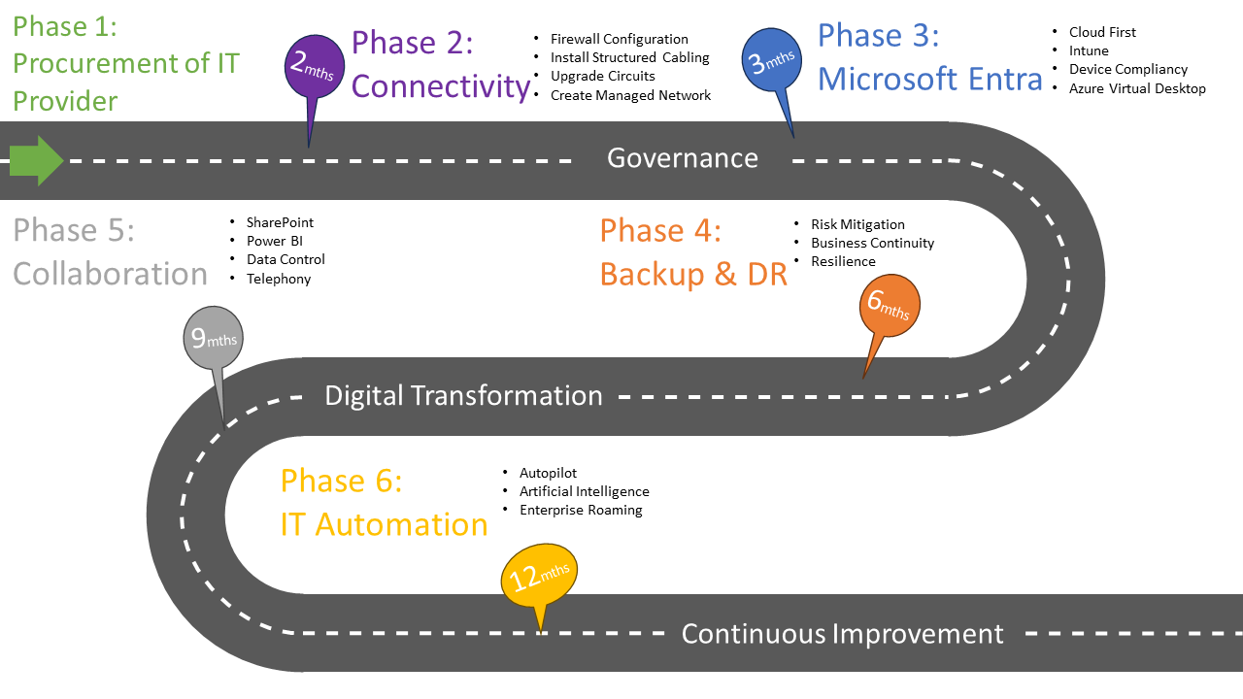
We are laying the foundation for digital transformation in order to achieve our strategic priorities, our roadmap emphasises the establishment of a robust infrastructure and fundamental policies. We recognise that the backbone of successful digital evolution lies in a well architected and resilient infrastructure. Concurrently, the formulation of comprehensive policies ensures the security, compliance and seamless operation of our digital ecosystem.

The dates in the timeline below are subject to change depending on procurement schedules and necessary adjustments to work that might be required during each phase.

Phase 1- Procurement (September 2024)
The initial phase involves securing a fully managed IT provider through the WLWA procurement process.
The emphasise for procurement will be around the user needs, reduce friction, seamless integration and migration. Design and user research in all relevant procurements will be vital.
Phase 2 – Connectivity (December 24)
Connectivity serves as a foundational element for the Authority. It plays a pivotal role in initiating and sustaining a digital transformation journey. It is the backbone for enhancing internal and external communication, fostering collaboration, and enabling seamless data exchange and agile decision making across diverse systems with access to resources.
2.1 Connectivity: Installation of a new leased line to improve the internet speed and remove a single point of failure from the network
2.2 Switches: Network security with switches involves controlling data flow and access, enhancing protection against unauthorised access, potential threats, fault find performance issues and reduce bottlenecks.
2.3 Structured Cabling: Structured cabling to be implemented across each West London Waste site. Although there is a limited amount of cabling connecting the office environment, the existing parts of the site rely on Wireless repeaters, leading to inconsistent connectivity.

2.4 Firewalls: Firewalls play a crucial role in digital transformation by safeguarding networks, ensuring secure data transmission, and protecting against cyber threats, thereby facilitating a resilient and secure foundation for transformative technologies and process. The sites will be interconnected by using IPsec tunnels creating a secure environment. We would also create firewall rules to allow traffic to breakout locally. This will enable communication between the sites, aid with physical site security and create an encrypted link to transfer data

Phase 3 – Microsoft Entra ID (January 25)
Following the implementation and configuration of Phase 2, the next step would be to start the process of migrating WLWA to utilise tools such as Intune as well as utilising Entra ID

Microsoft 365 Licencing: The current Microsoft 365 licencing (Business Standard) does not give the Authority the rights to use Entra AD or Intune (MDM). We plan on upgrading to Business premium to get the additional features and services, such as advanced security measures, collaboration tools and enhanced support, providing a comprehensive yet cost effective solution. This would further mean that we do not have to pay the additional cost of PowerBi pro licence per user.

3.1 Entra Active Directory Feature: Some of the main benefits of migrating are:

Cloud-based infrastructure: Entra AD is a cloud-based service, which if utilised could help the Authority avoid the costs and complexities of managing and maintaining on-premises infrastructure. This option brings in significant cost savings and greater scalability.
- Identity management: Entra AD provides robust identity management capabilities, including user authentication and authorization, single sign-on (SSO), and multi-factor authentication (MFA). This will help the Authority improve its security posture and simplify the management of user identities.
- Application integration: Entra AD is instrumental for digital transformation as it enables seamless communication and data exchange between diverse applications and services. Leveraging Entra’s integration services, the Authority can create a connected ecosystem, streamline workflows and enhance overall efficiency. .
- Device management: Entra AD also provides device management capabilities, including the ability to manage mobile devices and desktops. This can help Authority ensure that devices are secure and compliant with corporate policies.
- Collaboration: Entra AD can facilitate collaboration between users within the organisation and with external partners, customers, and suppliers. This can help businesses improve their agility and responsiveness to changing business needs

3.2 Microsoft Intune and Cloud Device Management: Mobile phones and other devices typically fall through the net unless a 3rd party application is introduced to perform this function. With the spread of devices across the different sites it makes sense to migrate the management of devices to Microsoft Intune. Microsoft Intune is a cloud-based Mobile Device Management (MDM) solution that allows businesses to manage and secure their mobile devices, including smartphones, tablets, and laptops. There are several benefits of using Microsoft Intune for mobile device management:
- Security: Microsoft Intune provides comprehensive security features that protect mobile devices from threats such as malware, data breaches, and unauthorized access. It allows businesses to enforce security policies and compliance standards, including password protection, device encryption, and remote wipe.
- Control: Microsoft Intune gives businesses greater control over their mobile devices, including the ability to manage settings, applications, and updates. It also allows administrators to manage access to corporate resources, including email, files, and other applications.
- Productivity: Microsoft Intune can help boost productivity by providing employees with the tools they need to work on the go. It allows employees to access corporate resources from their mobile devices, collaborate with colleagues, and stay connected to the business.
- Cost-effectiveness: Microsoft Intune is a cost-effective solution for mobile device management, as it eliminates the need for businesses to invest in on-premises infrastructure or hardware.

3.3 User Experience: Microsoft Intune provides a seamless user experience for employees, allowing them to access corporate resources and collaborate with colleagues from any location, on any device. It also allows them to work securely without compromising the organisation and their personal data.

3.4 Device Configuration Profiles: Microsoft Intune includes settings and features that can be enabled or disabled on different devices within the Authority. These settings and features are added to Configuration Profiles. Intune will be used to apply or assign the profile to the devices.

Some profile examples include:
- Deploying Bitlocker Encryption to supported devices.
- Deploying an Anti-Virus Product to support devices.
- On Windows 10/11 devices, use a profile template that blocks ActiveX controls in Internet Explorer.
- Allow or prevent access to Bluetooth on the device.
- Create a Wi-Fi or VPN profile that gives different devices access to your corporate network.
- Manage software updates, including when they're installed.
- Run a mobile device as dedicated kiosk device that can run one app or run many apps
- Leveraging Configuration Profiles would make it easier to deploy and update software across the business.

3.5 Device Compliance Policies: The compliance policy, will define a set of rules and settings that users and devices must meet to be considered compliant.
The following compliance rules would be used to check compatibility of the device as compliant or non-compliant.
- Anti-Virus is installed and up to date.
- Anti-Malware is installed and up to date.
- The device is not jail broken.
- The Operating system is at a certain level (typically current -1)

3.6 Virtual Desktop (optional): We want to maintain flexibility regarding the use of virtual desktops infrastructure (VDI’s) as a prudent approach, ensuring adaptability to evolving business needs and have left it as an optional feature. Rather than using Citrix remote desktop this could be changed to Citrix Virtual Apps which allows businesses to deliver applications to end-users on-demand, regardless of their location or the device they are using. Here are key benefits associated with Citrix Virtual Apps:
- Centralized Management: Administrators can centrally manage and deliver applications to end-users. This includes provisioning, updating, and securing applications, simplifying the overall management process.
- Application Isolation: Applications run in isolated environments, preventing conflicts between different applications. This ensures a more stable and reliable user experience.
- Support for Legacy Applications: Organizations with legacy applications that may not be compatible with newer operating systems can use Citrix Virtual Apps to deliver these applications to end-users efficiently.
- Scalability: The solution is scalable, allowing organizations to add or remove resources based on demand. This scalability ensures that the infrastructure can adapt to changing workloads.
As our proposed strategy of moving to Intune and Entra, this could be replaced by Azure Virtual Desktop (AVD), this is a Microsoft Azure service that enables businesses to deliver virtualized desktops and applications to end-users.

Phase 4 – Backup / Disaster Recovery (March 25)
Following the implementation of Entra AD, the next step would be to implement a robust backup and disaster recovery solution that meets the legislative requirements and protects West London Waste.

Backup: Implementation of a robust backup solution that would not only backup an on premise environment should one be required but also cloud to cloud would help protect WLWA. A backup solution will help with
- Risk Mitigation: Backups mitigate the risks associated with hardware failures, theft, natural disasters, and cybersecurity threats. By regularly backing up data to offsite locations, the impact of these risks can be minimized, ensuring that data remains accessible even in challenging circumstances.
- Protection against Data Loss: Backups serve as a safety net, protecting against data loss due to various unforeseen events such as system crashes, viruses, malware, or ransomware attacks. Without backups, losing data can have severe consequences for personal users and businesses alike.
- Compliance Requirements: Backups can help meet these compliance standards by providing a secure and accessible archive of historical information.

4.1 Business Continuity: Backups are crucial for maintaining operations during and after unexpected events. In the event of a disaster, having up-to-date backups enables a quicker recovery, reducing downtime and ensuring business continuity.

4.2 Disaster Recovery: Disaster recovery (DR) is a crucial aspect of business continuity planning that involves preparing for and recovering from potential disasters or disruptions that could impact the Authority’s IT infrastructure and operations. Here are some key benefits of implementing a robust disaster recovery plan:
- Business Continuity: The primary goal of disaster recovery is to ensure business continuity by minimizing downtime. By having a plan in place, the Authority can quickly recover critical systems and operations, reducing the impact of a disaster on daily business activities.
- Increased Resilience: A comprehensive disaster recovery plan shows resilience to various types of disruptions. This resilience can help the business adapt to unexpected challenges and continue operating even in the face of adversity.
- Compliance and Legal Requirements: Implementing a disaster recovery plan will help the Authority comply with regulatory compliance, avoiding potential legal issues and financial penalties.
- Risk Management: Disaster recovery is a key component of overall risk management. By identifying potential risks and developing strategies to mitigate them, the Authority can better protect its assets and reputation.

Phase 5 - Collaboration

WLWA is using Microsoft Teams, SharePoint, and OneDrive. However, this is used sporadically and in a disjoined manor with no centralised initiative in place currently to look at how WLWA can more effectively use these systems. We will put processes of measures and controls to be implemented to help utilise these solutions to increase the productivity of the Authority.

5.1 SharePoint Online and OneDrive: Moving from a traditional file server to SharePoint Online which is a cloud-based platform for document management, collaboration, and sharing. SharePoint Online offers several benefits:
- Accessibility: SharePoint Online is accessible from anywhere with an internet connection, making it easy to access your files on the go or from remote locations.
- Collaboration: SharePoint Online makes it easy for teams to work together on documents, with features like version control, co-authoring, and real-time editing.
- Security: SharePoint Online includes built-in security features like data encryption, access controls, and multi-factor authentication to help protect your files and data from unauthorised access.
- Scalability: SharePoint Online is a scalable solution that can grow with your business, providing storage space for your files as your needs change.
- Integration: SharePoint Online integrates with other Microsoft Office 365 applications, such as Teams and OneDrive, as well as with other third-party applications, making it easy to work with the tools you already use.
- Search ability: SharePoint Online allows you to search for files and documents using keywords, metadata, or custom filters, making it easier to find the content you need. Overall, SharePoint Online offers a more flexible, scalable, and collaborative solution for managing documents and files, making it an ideal choice for businesses that need to share and collaborate on content regularly.

5.2 Data Security / Control: Remote working and the shift to more cloud-based solutions. It is becoming ever more imperative that data controls and security is put in place to help safeguard the Authority’s IP and reduce the risk of a data breach. There are several ways of achieving these utilising different elements of Microsoft Suite(Purview).The proposed and continual use of Power BI for reporting these products can complement each other within an Authority’s broader data strategy. The main aspects of the Microsoft Purview product stack are.
- Unified data discovery: Purview provides a unified view of an organisation's data across various sources, making it easier to find and access data.
- Data lineage tracking: Purview tracks the lineage of data, which means it provides an understanding of the data's origin, transformations, and destination. This feature helps to ensure data accuracy and compliance.
- Data cataloguing: Purview provides a centralised catalogue of data assets, which makes it easier for data consumers to find and access the data they need.
- Compliance and security: Purview helps businesses to comply with data protection regulations, such as GDPR and CCPA, by providing tools for data classification, labelling, and access control.
- Collaboration: Purview provides collaboration features that allow teams to work together on data-related tasks.

5.3 Telephony: With the increase in remote working Microsoft Teams calling is becoming increasingly important to have the ability to have our landline phone on the move and on any device. Some of the key advantages include.
- Voice and Video Calls: Teams provides a robust telephony solution, allowing users to make voice and video calls directly from the platform. This feature is particularly beneficial for remote or distributed teams.
- Integration with Microsoft 365: Teams is tightly integrated with the Microsoft 365 suite, providing seamless access to applications like Outlook, Word, Excel, and SharePoint. This integration enhances productivity by centralizing tools and information.
- Mobility: Teams' telephony features are accessible on various devices, including desktop computers, laptops, tablets, and mobile phones. This mobility empowers users to stay connected and engaged regardless of their location.
- Cost Savings: By consolidating communication and collaboration tools into one platform, organizations may experience cost savings in terms of licensing, infrastructure, and maintenance.

Phase 6 – IT Automation (June 25)

With the transition to Microsoft Entra this opens additional enhancements that can be leveraged to help both the IT team and the staff. The main three elements I would advise the initial focus on is below.

Self Service Password Reset (SSPR): Leveraging Entra AD for user authentication allows for the configuration of Self-Service Password Resets. Once configured this will allow users to reset their own passwords, improving the user experience as they will be able to get back into their account faster and any time of the day.

Windows Autopilot: Windows Autopilot is a collection of technologies used to set up and pre-configure new devices, getting them ready for productive use. Windows Autopilot can be used to deploy Windows PCs remotely helping to speed up the deployment process. Windows devices that are currently in use can also be retrospectively enrolled into this solution with minimal work. You can also use Windows Autopilot to reset, repurpose, and recover devices. Windows Autopilot simplifies the Windows device lifecycle, for both IT and end users, from initial deployment to end of life. Using cloud-based services, Windows Autopilot:

6.3 Enterprise State Roaming: Enterprise State Roaming lets users securely synchronise user and application settings data to the cloud. This means they will have the same experience no matter which Windows device they sign into. . This can only be configured using Entra AD.

7 Other Recommendations

Below recommendations can be implemented at any stage or are dependent on existing contracts being up for renewal.
Creating a fully functional and interactive website that serves as a one stop shop for both internal and external users involves careful planning and execution. A detailed project plan will be provided for this in due course as we need to set the foundation. Key considerations would be user experience, security and integration of necessary features.

8. Policies (April24 – December24)

There needs to be clear and defined policies and procedures that are stored in a central location easily accessible by all employees. As a base, an IT Policy will be created with the following topics covered:

- Password Security
- IT Acceptable Use
- Cyber Policy
- Cloud and App Use
- Bring Your Own Device (BYOD)
- Information Security
- Incident Response
- Business Continuity
- Data Backup and Recovery
- Network Security
- Security and Privacy User
- Local Admin Usage
- Removable Media
- Data Transfer
- Remote Working
- Social Media
- Security Incident Response

